Captcha Recognition Using CNN

1 INTRODUCTION
CAPTCHA (Completely Automated Public Turing Test to tell Computers and Humans Apart) is an automated test created to prevent websites from being repeatedly accessed by an automatic program in a short period of time and wasting network resources. Most service providers online have implemented CAPTCHA tests before the user is allowed to commit certain actions, such as submitting a form. Among all the CAPTCHAs, commonly used types contain low resolution, deformed characters with character adhesions and background noise, which the user must read and type correctly into an input box. This is a relatively simple task for humans, taking an average of 10 seconds to solve [1], but it presents a difficulty for computers, because such noise makes it difficult for a program to differentiate the characters from them. However, using Convolutional Neural Networks (CNN), these CAPTCHA tests could be solved efficiently and accurately by computers. Creating a simple, efficient and accurate method to recognize CAPTCHAs can assist with the verification of the security of existing forms of CAPTCHAs and the creation of new, more secure ones. The same approach for CAPTCHA recognition could also be applied in several other fields, including handwriting recognition, license plate recognition, and many more. The focus of our research is to optimize a CNN model for structural simplicity, accuracy, and amount of training data required. To further improve the accuracy of the models and decrease the training data needed, we also experimented with preprocessing the CAPTCHA images using methods such as Fourier Transform with the goal of eliminating background noise.

Objective of the project:
CAPTCHAs are automated tests designed to distinguish between humans and computers. They could be easily solved by humans, but they become challenging for machines to solve, therefore preventing programs from abusing online services and occupying internet resources. Using Convolutional Neural Networks, the CAPTCHA tests could be solved automatically at high efficiency. Current approaches of high accuracy CAPTCHA recognition can be structurally complicated. As a result, our team explored a different approach to solve CAPTCHAs using a Convolutional Neural Network that is more efficient in terms of structural complexity and run time, with image processing being a possibility to enhance the accuracy. We also tested our networks on CAPTCHA datasets with character adhesion and background noise.

2. LITERATURE SURVEY
How good are humans at solving CAPTCHAs
Captchas are designed to be easy for humans but hard for machines. However, most recent research has focused only on making them hard for machines. In this paper, we present what is to the best of our knowledge the first large scale evaluation of captchas from the human perspective, with the goal of assessing how much friction captchas present to the average user. For the purpose of this study we have asked workers from Amazon's Mechanical Turk and an underground captchabreaking service to solve more than 318 000 captchas issued from the 21 most popular captcha schemes (13 images schemes and 8 audio scheme). Analysis of the resulting data reveals that captchas are often difficult for humans, with audio captchas being particularly problematic. We also find some demographic trends indicating, for example, that non-native speakers of English are slower in general and less accurate on English-centric captcha schemes. Evidence from a week's worth of eBay captchas (14,000,000 samples) suggests that the solving accuracies found in our study are close to real-world values, and that improving audio captchas should become a priority, as nearly 1% of all captchas are delivered as audio rather than images. Finally our study also reveals that it is more effective for an attacker to use Mechanical Turk to solve captchas than an underground service.

Gradient-based learning applied to document recognition
Multilayer neural networks trained with the back-propagation algorithm constitute the best example of a successful gradient based learning technique. Given an appropriate network architecture, gradient-based learning algorithms can be used to synthesize a complex decision surface that can classify high-dimensional patterns, such as handwritten characters, with minimal preprocessing. This paper reviews various methods applied to handwritten character recognition and compares them on a standard handwritten digit recognition task. Convolutional neural networks, which are specifically designed to deal with the variability of 2D shapes, are shown to outperform all other techniques. Real-life document recognition systems are composed of multiple modules including field extraction, segmentation recognition, and language modeling. A new learning paradigm, called graph transformer networks (GTN), allows such multimodule systems to be trained globally using gradient-based methods so as to minimize an overall performance measure. Two systems for online handwriting recognition are described. Experiments demonstrate the advantage of global training, and the flexibility of graph transformer networks. A graph transformer network for reading a bank cheque is also described. It uses convolutional neural network character recognizers combined with global training techniques to provide record accuracy on business and personal cheques. It is deployed commercially and reads several million cheques per day.

Multi-digit number recognition from street view imagery using deep convolutional neural networks
Recognizing arbitrary multi-character text in unconstrained natural photographs is a hard problem. In this paper, we address an equally hard sub-problem in this domain viz. recognizing arbitrary multi-digit numbers from Street View imagery. Traditional approaches to solve this problem typically separate out the localization, segmentation, and recognition steps. In this paper we propose a unified approach that integrates these three steps via the use of a deep convolutional neural network that operates directly on the image pixels. We employ the DistBelief implementation of deep neural networks in order to train large, distributed neural networks on high quality images. We find that the performance of this approach increases with the depth of the convolutional network, with the best performance occurring in the deepest architecture we trained, with eleven hidden layers. We evaluate this approach on the publicly available SVHN dataset and achieve over 96% accuracy in recognizing complete street numbers. We show that on a per-digit recognition task, we improve upon the state-of-the-art, achieving 97.84% accuracy. We also evaluate this approach on an even more challenging dataset generated from Street View imagery containing several tens of millions of street number annotations and achieve over 90% accuracy. To further explore the applicability of the proposed system to broader text recognition tasks, we apply it to synthetic distorted text from reCAPTCHA. reCAPTCHA is one of the most secure reverse turing tests that uses distorted text to distinguish humans from bots. We report a 99.8% accuracy on the hardest category of reCAPTCHA. Our evaluations on both tasks indicate that at specific operating thresholds, the performance of the proposed system is comparable to, and in some cases exceeds, that of human operators.

CAPTCHA recognition method based on LSTM RNN
Completely automated public turing test to tell computers and humans apart (CAPTCHA) is a kind of network security mechanism based on hard artificial problems. Study of recognition of CAPTCHA impels it to become more secure, and some hard atifical problems to be solved. Firstly, CAPTCHA recognition methods of state of the art are analyzed. Then, a recognition method is brought up based on recurrent neural network (RNN) which is composed by long short-term memory (LSTM) blocks. Thirdly, feature extraction for CAPTCHA recognition is studied. Finally, a decoding algorithm is proposed to improve the recognition rate. Experimental results show that the proposed recognition method is efficient. Gray value of images is proved to be a kind of good feature for RNN. Furthermore, the proposed decoding algorithm gets high recognition rates with low time complexity.

A low-cost attack on a Microsoft CAPTCHA
In this paper, we present new character segmentation techniques of general value to attack a number of text CAPTCHAs, including the schemes designed and deployed by Microsoft, Yahoo and Google. In particular, the Microsoft CAPTCHA has been deployed since 2002 at many of their online services including Hotmail, MSN and Windows Live. Designed to be segmentation-resistant, this scheme has been studied and tuned by its designers over the years. However, our simple attack has achieved a segmentation success rate of higher than 90% against this scheme. It took on average ~80 ms for the attack to completely segment a challenge on an ordinary desktop computer. As a result, we estimate that this CAPTCHA could be instantly broken by a malicious bot with an overall (segmentation and then recognition) success rate of more than 60%. On the contrary, the design goal was that automated attacks should not achieve a success rate of higher than 0.01%. For the first time, this paper shows that CAPTCHAs that are carefully designed to be segmentation-resistant are vulnerable to novel but simple attacks

3 .SYSTEM ANALYSIS
3.1 Existing System
Most service providers online have implemented CAPTCHA tests before the user is allowed to commit certain actions, such as submitting a form. Among all the CAPTCHAs, commonly used types contain low resolution, deformed characters with character adhesions and background noise, which the user must read and type correctly into an input box. Other deep learning algorithms like RNN and LSTM are unable to extract or segment selection from the given CAPTCHA image features.

PROPOSED SYSTEM
Based on existing methods of recognition, we built three CNN networks for testing. These networks do not necessarily have fewer parameters than other networks, but they have less runtime and complexity compared to other CNN networks such as DenseNet. It shows the structure of our first network, Network 1. In the first network, the image initially undergoes three convolutions. Two transition layers with a structure constructed by MaxPool → Batch Normalization (BN) → ReLU are inserted between the three convolutions to implement down-sampling. The third convolution is followed by a BN, a MaxPool, after which the model is flattened.
MODULES

- Data Collection: Using this module we will upload CAPTCHA image dataset to application
- Data Preprocessing: using this module we will read all CAPTCHA image and after applying Preprocessing we will extract features from all reviews.
- Train CNN Algorithm: we are trainging the cnn algorithm with the dataset
- Predict Captcha: we are predicting the CAPTCHA by giving the test images

3.3. PROCESS MODEL USED WITH JUSTIFICATION
SDLC (Umbrella Model):
Umbrella Activity
Umbrella Activity
Umbrella Activity
- Feasibility Study
- TEAM FORMATION
- Project Specification PREPARATION

Business Requirement Documentation
ANALYSIS & DESIGN
CODE
UNIT TEST
DOCUMENT CONTROL

ASSESSMENT

TRAINING
INTEGRATION & SYSTEM TESTING

DELIVERY/INSTALLATION
ACCEPTANCE TEST
Requirements Gathering
SDLC is nothing but Software Development Life Cycle. It is a standard which is used by software industry to develop good software.
Stages in SDLC:
- Requirement Gathering
- Analysis
- Designing
- Coding
- Testing
- Maintenance
Requirements Gathering stage:
The requirements gathering process takes as its input the goals identified in the high-level requirements section of the project plan. Each goal will be refined into a set of one or more requirements. These requirements define the major functions of the intended application, define operational data areas and reference data areas, and define the initial data entities. Major functions include critical processes to be managed, as well as mission critical inputs, outputs and reports. A user class hierarchy is developed and associated with these major functions, data areas, and data entities. Each of these definitions is termed a Requirement. Requirements are identified by unique requirement identifiers and, at minimum, contain a requirement title and textual description.
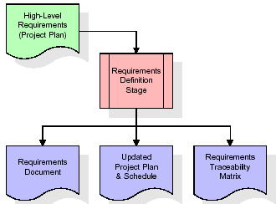
These requirements are fully described in the primary deliverables for this stage: the Requirements Document and the Requirements Traceability Matrix (RTM). The requirements document contains complete descriptions of each requirement, including diagrams and references to external documents as necessary. Note that detailed listings of database tables and fields are not included in the requirements document.
The title of each requirement is also placed into the first version of the RTM, along with the title of each goal from the project plan. The purpose of the RTM is to show that the product components developed during each stage of the software development lifecycle are formally connected to the components developed in prior stages.
In the requirements stage, the RTM consists of a list of high-level requirements, or goals, by title, with a listing of associated requirements for each goal, listed by requirement title. In this hierarchical listing, the RTM shows that each requirement developed during this stage is formally linked to a specific product goal. In this format, each requirement can be traced to a specific product goal, hence the term requirements traceability.
The outputs of the requirements definition stage include the requirements document, the RTM, and an updated project plan.
- Feasibility study is all about identification of problems in a project.
- No. of staff required to handle a project is represented as Team Formation, in this case only modules are individual tasks will be assigned to employees who are working for that project.
- Project Specifications are all about representing of various possible inputs submitting to the server and corresponding outputs along with reports maintained by administrator.
Analysis Stage:
The planning stage establishes a bird's eye view of the intended software product, and uses this to establish the basic project structure, evaluate feasibility and risks associated with the project, and describe appropriate management and technical approaches.
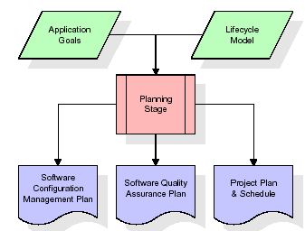
The most critical section of the project plan is a listing of high-level product requirements, also referred to as goals. All of the software product requirements to be developed during the requirements definition stage flow from one or more of these goals. The minimum information for each goal consists of a title and textual description, although additional information and references to external documents may be included. The outputs of the project planning stage are the configuration management plan, the quality assurance plan, and the project plan and schedule, with a detailed listing of scheduled activities for the upcoming Requirements stage, and high level estimates of effort for the out stages.
Designing Stage:
The design stage takes as its initial input the requirements identified in the approved requirements document. For each requirement, a set of one or more design elements will be produced as a result of interviews, workshops, and/or prototype efforts. Design elements describe the desired software features in detail, and generally include functional hierarchy diagrams, screen layout diagrams, tables of business rules, business process diagrams, pseudo code, and a complete entity-relationship diagram with a full data dictionary. These design elements are intended to describe the software in sufficient detail that skilled programmers may develop the software with minimal additional input.

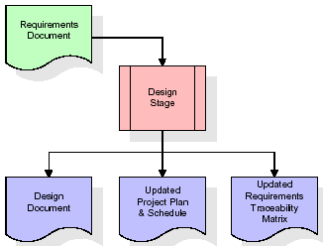
When the design document is finalized and accepted, the RTM is updated to show that each design element is formally associated with a specific requirement. The outputs of the design stage are the design document, an updated RTM, and an updated project plan.
Development (Coding) Stage:
The development stage takes as its primary input the design elements described in the approved design document. For each design element, a set of one or more software artifacts will be produced. Software artifacts include but are not limited to menus, dialogs, and data management forms, data reporting formats, and specialized procedures and functions. Appropriate test cases will be developed for each set of functionally related software artifacts, and an online help system will be developed to guide users in their interactions with the software.
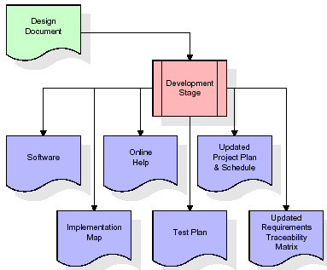

The RTM will be updated to show that each developed artifact is linked to a specific design element, and that each developed artifact has one or more corresponding test case items. At this point, the RTM is in its final configuration. The outputs of the development stage include a fully functional set of software that satisfies the requirements and design elements previously documented, an online help system that describes the operation of the software, an implementation map that identifies the primary code entry points for all major system functions, a test plan that describes the test cases to be used to validate the correctness and completeness of the software, an updated RTM, and an updated project plan.

Integration & Test Stage:
During the integration and test stage, the software artifacts, online help, and test data are migrated from the development environment to a separate test environment. At this point, all test cases are run to verify the correctness and completeness of the software. Successful execution of the test suite confirms a robust and complete migration capability. During this stage, reference data is finalized for production use and production users are identified and linked to their appropriate roles. The final reference data (or links to reference data source files) and production user list are compiled into the Production Initiation Plan.
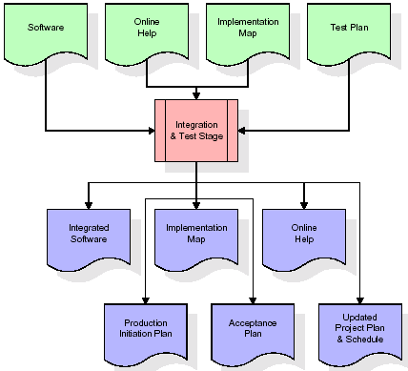
The outputs of the integration and test stage include an integrated set of software, an online help system, an implementation map, a production initiation plan that describes reference data and production users, an acceptance plan which contains the final suite of test cases, and an updated project plan.
- Installation & Acceptance Test:
During the installation and acceptance stage, the software artefacts, online help, and initial production data are loaded onto the production server. At this point, all test cases are run to verify the correctness and completeness of the software. Successful execution of the test suite is a prerequisite to acceptance of the software by the customer.
After customer personnel have verified that the initial production data load is correct and the test suite has been executed with satisfactory results, the customer formally accepts the delivery of the software.
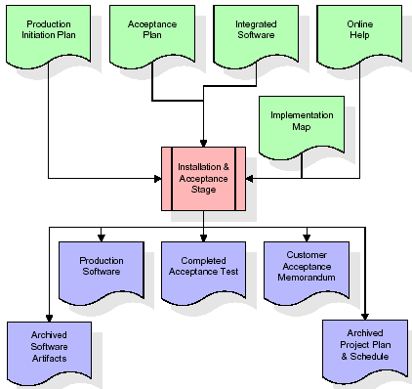
The primary outputs of the installation and acceptance stage include a production application, a completed acceptance test suite, and a memorandum of customer acceptance of the software. Finally, the PDR enters the last of the actual labour data into the project schedule and locks the project as a permanent project record. At this point the PDR "locks" the project by archiving all software items, the implementation map, the source code, and the documentation for future reference.
Maintenance:
Outer rectangle represents maintenance of a project, Maintenance team will start with requirement study, understanding of documentation later employees will be assigned work and they will undergo training on that particular assigned category. For this life cycle there is no end, it will be continued so on like an umbrella (no ending point to umbrella sticks).
3.4. Software Requirement Specification
3.4.1. Overall Description
A Software Requirements Specification (SRS) – a requirements specification for a software system is a complete description of the behaviour of a system to be developed. It includes a set of use cases that describe all the interactions the users will have with the software. In addition to use cases, the SRS also contains non-functional requirements. Non-functional requirements are requirements which impose constraints on the design or implementation (such as performance engineering requirements, quality standards, or design constraints).
System requirements specification: A structured collection of information that embodies the requirements of a system. A business analyst, sometimes titled system analyst, is responsible for analyzing the business needs of their clients and stakeholders to help identify business problems and propose solutions. Within the systems development lifecycle domain, the BA typically performs a liaison function between the business side of an enterprise and the information technology department or external service providers. Projects are subject to three sorts of requirements:
- Business requirements describe in business terms what must be delivered or accomplished to provide value.
- Product requirements describe properties of a system or product (which could be one of several ways to accomplish a set of business requirements.)
- Process requirements describe activities performed by the developing organization. For instance, process requirements could specify .Preliminary investigation examine project feasibility, the likelihood the system will be useful to the organization. The main objective of the feasibility study is to test the Technical, Operational and Economical feasibility for adding new modules and debugging old running system. All system is feasible if they are unlimited resources and infinite time. There are aspects in the feasibility study portion of the preliminary investigation:
- ECONOMIC FEASIBILITY
A system can be developed technically and that will be used if installed must still be a good investment for the organization. In the economical feasibility, the development cost in creating the system is evaluated against the ultimate benefit derived from the new systems. Financial benefits must equal or exceed the costs. The system is economically feasible. It does not require any addition hardware or software. Since the interface for this system is developed using the existing resources and technologies available at NIC, There is nominal expenditure and economical feasibility for certain.
- Operational Feasibility
Proposed projects are beneficial only if they can be turned out into information system. That will meet the organization’s operating requirements. Operational feasibility aspects of the project are to be taken as an important part of the project implementation. This system is targeted to be in accordance with the above-mentioned issues. Beforehand, the management issues and user requirements have been taken into consideration. So there is no question of resistance from the users that can undermine the possible application benefits. The well-planned design would ensure the optimal utilization of the computer resources and would help in the improvement of performance status.
- TECHNICAL FEASIBILITY
Earlier no system existed to cater to the needs of ‘Secure Infrastructure Implementation System’. The current system developed is technically feasible. It is a web based user interface for audit workflow at NIC-CSD. Thus it provides an easy access to .the users. The database’s purpose is to create, establish and maintain a workflow among various entities in order to facilitate all concerned users in their various capacities or roles. Permission to the users would be granted based on the roles specified. Therefore, it provides the technical guarantee of accuracy, reliability and security.
3.4.2. External Interface Requirements
REQUIREMENT ANALYSIS
The project involved analyzing the design of few applications so as to make the application more users friendly. To do so, it was really important to keep the navigations from one screen to the other well ordered and at the same time reducing the amount of typing the user needs to do. In order to make the application more accessible, the browser version had to be chosen so that it is compatible with most of the Browsers.
REQUIREMENT SPECIFICATION
HARDWARE REQUIREMENTS:
- System : Pentium IV 2.4 GHz.
- Hard Disk : 40 GB.
- Floppy Drive : 1.44 Mb.
- Monitor : 14’ Colour Monitor.
- Mouse : Optical Mouse.
- Ram : 512 Mb.
SOFTWARE REQUIREMENTS:
- Operating system : Windows 7 Ultimate.
- Coding Language : Python.
- Front-End : Python.
- Designing : Html,css,javascript.
- Data Base : MySQL.

4. SYSTEM DESIGN
UML Diagram:
Class Diagram:
The class diagram is the main building block of object oriented modeling. It is used both for general conceptual modeling of the systematic of the application, and for detailed modeling translating the models into programming code. Class diagrams can also be used for data modeling. The classes in a class diagram represent both the main objects, interactions in the application and the classes to be programmed. In the diagram, classes are represented with boxes which contain three parts:
- The upper part holds the name of the class
- The middle part contains the attributes of the class
- The bottom part gives the methods or operations the class can take or undertake
Class Diagram:

Use case Diagram:
A use case diagram at its simplest is a representation of a user's interaction with the system and depicting the specifications of a use case. A use case diagram can portray the different types of users of a system and the various ways that they interact with the system. This type of diagram is typically used in conjunction with the textual use case and will often be accompanied by other types of diagrams as well.
Use case Diagram:

Sequence diagram:
A sequence diagram is a kind of interaction diagram that shows how processes operate with one another and in what order. It is a construct of a Message Sequence Chart. A sequence diagram shows object interactions arranged in time sequence. It depicts the objects and classes involved in the scenario and the sequence of messages exchanged between the objects needed to carry out the functionality of the scenario. Sequence diagrams are typically associated with use case realizations in the Logical View of the system under development. Sequence diagrams are sometimes called event diagrams, event scenarios, and timing diagrams.

Collaboration diagram:
A collaboration diagram describes interactions among objects in terms of sequenced messages. Collaboration diagrams represent a combination of information taken from class, sequence, and use case diagrams describing both the static structure and dynamic behavior of a system.

Component Diagram:
In the Unified Modelling Language, a component diagram depicts how components are wired together to form larger components and or software systems. They are used to illustrate the structure of arbitrarily complex systems.
Components are wired together by using an assembly connector to connect the required interface of one component with the provided interface of another component. This illustrates the service consumer - service provider relationship between the two components.
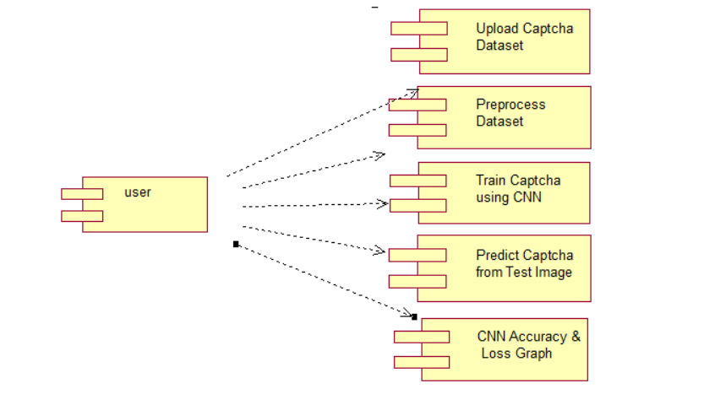

Deployment Diagram:
A deployment diagram in the Unified Modeling Language models the physical deployment of artifacts on nodes. To describe a web site, for example, a deployment diagram would show what hardware components ("nodes") exist (e.g., a web server, an application server, and a database server), what software components ("artifacts") run on each node (e.g., web application, database), and how the different pieces are connected (e.g. JDBC, REST, RMI).
The nodes appear as boxes, and the artifacts allocated to each node appear as rectangles within the boxes. Nodes may have sub nodes, which appear as nested boxes. A single node in a deployment diagram may conceptually represent multiple physical nodes, such as a cluster of database servers.
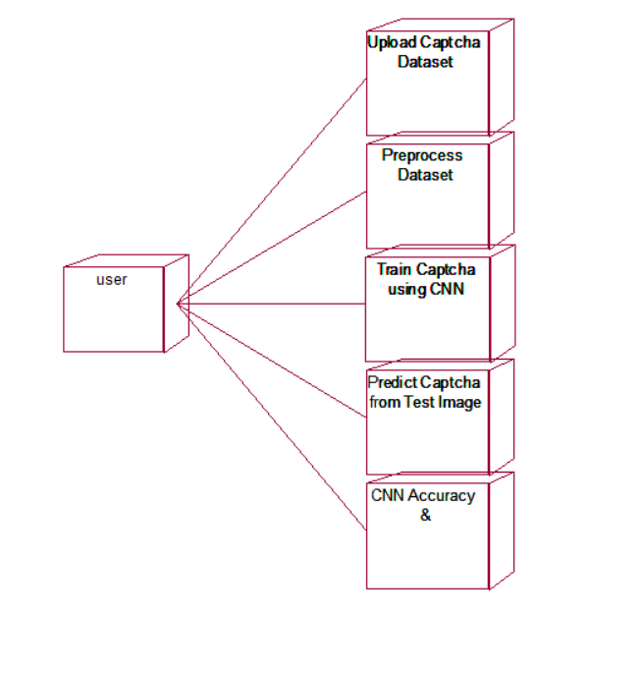

Activity Diagram:
Activity diagram is another important diagram in UML to describe dynamic aspects of the system. It is basically a flow chart to represent the flow form one activity to another activity. The activity can be described as an operation of the system. So the control flow is drawn from one operation to another. This flow can be sequential, branched or concurrent

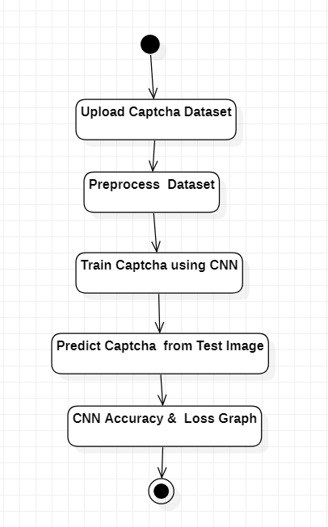

5. IMPLEMETATION
5.1 Python
Python is a general-purpose language. It has wide range of applications from Web development (like: Django and Bottle), scientific and mathematical computing (Orange, SymPy, NumPy) to desktop graphical user Interfaces (Pygame, Panda3D). The syntax of the language is clean and length of the code is relatively short. It's fun to work in Python because it allows you to think about the problem rather than focusing on the syntax.
History of Python:
Python is a fairly old language created by Guido Van Rossum. The design began in the late 1980s and was first released in February 1991.
Why Python was created?
In late 1980s, Guido Van Rossum was working on the Amoeba distributed operating system group. He wanted to use an interpreted language like ABC (ABC has simple easy-to-understand syntax) that could access the Amoeba system calls. So, he decided to create a language that was extensible. This led to design of a new language which was later named Python.
Why the name Python?
No. It wasn't named after a dangerous snake. Rossum was fan of a comedy series from late seventies. The name "Python" was adopted from the same series "Monty Python's Flying Circus".

Features of Python:
A simple language which is easier to learn
Python has a very simple and elegant syntax. It's much easier to read and write Python programs compared to other languages like: C++, Java, C#. Python makes programming fun and allows you to focus on the solution rather than syntax.
If you are a newbie, it's a great choice to start your journey with Python.
Free and open-source
You can freely use and distribute Python, even for commercial use. Not only can you use and distribute software’s written in it, you can even make changes to the Python's source code.
Python has a large community constantly improving it in each iteration.
Portability
You can move Python programs from one platform to another, and run it without any changes.
It runs seamlessly on almost all platforms including Windows, Mac OS X and Linux.
Extensible and Embeddable
Suppose an application requires high performance. You can easily combine pieces of C/C++ or other languages with Python code.
This will give your application high performance as well as scripting capabilities which other languages may not provide out of the box.
A high-level, interpreted language
Unlike C/C++, you don't have to worry about daunting tasks like memory management, garbage collection and so on.
Likewise, when you run Python code, it automatically converts your code to the language your computer understands. You don't need to worry about any lower-level operations.
Large standard libraries to solve common tasks
Python has a number of standard libraries which makes life of a programmer much easier since you don't have to write all the code yourself. For example: Need to connect MySQL database on a Web server? You can use MySQLdb library using import MySQLdb .
Standard libraries in Python are well tested and used by hundreds of people. So you can be sure that it won't break your application.
Object-oriented
Everything in Python is an object. Object oriented programming (OOP) helps you solve a complex problem intuitively.
With OOP, you are able to divide these complex problems into smaller sets by creating objects.
Applications of Python:
1. Simple Elegant Syntax
Programming in Python is fun. It's easier to understand and write Python code. Why? The syntax feels natural. Take this source code for an example:
a = 2
b = 3
sum = a + b
print(sum)
2. Not overly strict
You don't need to define the type of a variable in Python. Also, it's not necessary to add semicolon at the end of the statement.
Python enforces you to follow good practices (like proper indentation). These small things can make learning much easier for beginners.
3. Expressiveness of the language
Python allows you to write programs having greater functionality with fewer lines of code. Here's a link to the source code of Tic-tac-toe game with a graphical interface and a smart computer opponent in less than 500 lines of code. This is just an example. You will be amazed how much you can do with Python once you learn the basics.
4. Great Community and Support
Python has a large supporting community. There are numerous active forums online which can be handy if you are stuck.

5.2 Sample Code:

Captcha Recognition Using CNN.py
from tkinter import messagebox
from tkinter import *
from tkinter import simpledialog
import tkinter
from tkinter import filedialog
from tkinter.filedialog import askopenfilename
import cv2
import numpy as np
from keras.models import model_from_json
import pickle
import os
from keras import layers #for building layers of neural net
from keras.models import Model
from keras.models import load_model
from keras import callbacks
import string
import matplotlib.pyplot as plt

main = tkinter.Tk()
main.title("Captcha Recognition Using CNN")
main.geometry("1300x1200")

global filename
global model
global character, nchar
global X, Y

def uploadDataset():
global filename
global labels
labels = []
filename = filedialog.askdirectory(initialdir=".")
pathlabel.config(text=filename)
text.delete('1.0', END)
text.insert(END,filename+" loaded\n\n");

def preprocessDataset():
global X, Y
global character, nchar
text.delete('1.0', END)
character = string.ascii_lowercase + "0123456789"
nchar = len(character)
X = np.zeros((1070,50,200,1))
Y = np.zeros((5,1070,nchar))
X = np.load("models/X.txt.npy")
Y = np.load("models/Y.txt.npy")
text.insert(END,"Total images found in dataset after processing : "+str(X.shape[0])+"\n")
text.insert(END,"Total characters using to train CNN : "+str(nchar)+"\n")
text.insert(END,"Characters list : "+str(character))

test = X[12]
test = cv2.resize(test,(200,200))
cv2.imshow("Processed Image",test)
cv2.waitKey(0)

def createmodel():
img = layers.Input(shape=(50,200,1)) # Get image as an input of size 50,200,1
conv1 = layers.Conv2D(16, (3, 3), padding='same', activation='relu')(img) #50*200
mp1 = layers.MaxPooling2D(padding='same')(conv1) # 25*100
conv2 = layers.Conv2D(32, (3, 3), padding='same', activation='relu')(mp1)
mp2 = layers.MaxPooling2D(padding='same')(conv2) # 13*50
conv3 = layers.Conv2D(32, (3, 3), padding='same', activation='relu')(mp2)
bn = layers.BatchNormalization()(conv3) #to improve the stability of model
mp3 = layers.MaxPooling2D(padding='same')(bn) # 7*25

flat = layers.Flatten()(mp3) #convert the layer into 1-D

outs = []
for _ in range(5): #for 5 letters of captcha
dens1 = layers.Dense(64, activation='relu')(flat)
drop = layers.Dropout(0.5)(dens1) #drops 0.5 fraction of nodes
res = layers.Dense(nchar, activation='sigmoid')(drop)

outs.append(res) #result of layers

# Compile model and return it
model = Model(img, outs) #create model
model.compile(loss='categorical_crossentropy', optimizer='adam',metrics=["accuracy"])
return model

def trainCNN():
global model
text.delete('1.0', END)
global X, Y
global character, nchar
X_train, y_train = X[:970], Y[:, :970]
X_test, y_test = X[970:], Y[:, 970:]
if os.path.exists('models/model.json'):
with open('models/model.json', "r") as json_file:
loaded_model_json = json_file.read()
model = model_from_json(loaded_model_json)
json_file.close()
model.load_weights("models/model_weights.h5")
model._make_predict_function()
else:
model = createmodel()
hist = model.fit(X, [Y[0], Y[1], Y[2], Y[3], Y[4]], batch_size=32, epochs=25)
model.save_weights('models/model_weights.h5')
model_json = model.to_json()
with open("models/model.json", "w") as json_file:
json_file.write(model_json)
json_file.close()
f = open('models/history.pckl', 'wb')
pickle.dump(hist.history, f)
f.close()
model.compile(loss='categorical_crossentropy', optimizer='adam',metrics=["accuracy"])
preds = model.evaluate(X_test, [y_test[0], y_test[1], y_test[2], y_test[3], y_test[4]])
text.insert(END,"CNN Captcha model generated with Loss on testing data : " + str(preds[0]))

def predictCaptcha():
text.delete('1.0', END)
filename = filedialog.askopenfilename(initialdir="testImages")
img = cv2.imread(filename, cv2.IMREAD_GRAYSCALE)
img = img / 255.0
res = np.array(model.predict(img[np.newaxis, :, :, np.newaxis]))
result = np.reshape(res, (5, 36))
k_ind = []
probs = []
for i in result:
k_ind.append(np.argmax(i))
capt = ''
for k in k_ind:
capt += character[k]
text.insert(END,'Captcha Recognized as : '+capt)
img = cv2.imread(filename)
img = cv2.resize(img, (600,400))
cv2.putText(img, 'Captcha Recognized as : '+capt, (10, 25), cv2.FONT_HERSHEY_SIMPLEX,0.7, (255, 0, 0), 2)
cv2.imshow('Captcha Recognized as : '+capt, img)
cv2.waitKey(0)

def graph():
f = open('models/history.pckl', 'rb')
data = pickle.load(f)
f.close()
accuracy = data['dense_4_accuracy']
loss = data['dense_4_loss']

plt.figure(figsize=(10,6))
plt.grid(True)
plt.xlabel('Epoch')
plt.ylabel('Accuracy/Loss')
plt.plot(loss, 'ro-', color = 'red')
plt.plot(accuracy, 'ro-', color = 'green')
plt.legend(['Loss', 'Accuracy'], loc='upper left')
plt.title('Captcha CNN Accuracy & Loss Graph')
plt.show()

font = ('times', 15, 'bold')
title = Label(main, text='Captcha Recognition Using CNN',anchor=W, justify=CENTER)
title.config(bg='yellow4', fg='white')
title.config(font=font)
title.config(height=3, width=120)
title.place(x=0,y=5)

font1 = ('times', 13, 'bold')
upload = Button(main, text="Upload Captcha Dataset", command=uploadDataset)
upload.place(x=50,y=100)
upload.config(font=font1)

pathlabel = Label(main)
pathlabel.config(bg='yellow4', fg='white')
pathlabel.config(font=font1)
pathlabel.place(x=50,y=150)

preprocessButton = Button(main, text="Preprocess Dataset", command=preprocessDataset)
preprocessButton.place(x=50,y=200)
preprocessButton.config(font=font1)

trainButton = Button(main, text="Train Captcha using CNN", command=trainCNN)
trainButton.place(x=50,y=250)
trainButton.config(font=font1)

predictButton = Button(main, text="Predict Captcha from Test Image", command=predictCaptcha)
predictButton.place(x=50,y=300)
predictButton.config(font=font1)

graphButton = Button(main, text="CNN Accuracy & Loss Graph", command=graph)
graphButton.place(x=50,y=350)
graphButton.config(font=font1)

font1 = ('times', 12, 'bold')
text=Text(main,height=15,width=78)
scroll=Scrollbar(text)
text.configure(yscrollcommand=scroll.set)
text.place(x=450,y=100)
text.config(font=font1)

main.config(bg='magenta3')
main.mainloop()

test.py
import numpy as np
import cv2
import string
import os
import matplotlib.pyplot as plt #for graphs
import os #for operating system dependent fucntionality
from keras import layers #for building layers of neural net
from keras.models import Model
from keras.models import load_model
from keras import callbacks
from keras.models import model_from_json
import pickle
'''
X = np.zeros((1070,50,200,1))

character= string.ascii_lowercase + "0123456789"
nchar = len(character)
print(nchar)
Y = np.zeros((5,1070,nchar))

for i, directory in enumerate(os.listdir("Dataset")):
if 'Thumbs.db' not in directory:
img_name = directory.split(".")
img_name = img_name[0].lower()
img = cv2.imread("Dataset/"+directory,cv2.IMREAD_GRAYSCALE)
img = img / 255.0
img = np.reshape(img, (50, 200, 1))
target = np.zeros((5,nchar))
for k in range(len(img_name)):
name = img_name[k]
index = character.find(name)
#print(str(k)+" "+name+" "+str(index))
target[k, index] = 1
print(directory+" "+img_name+" "+str(target))
X[i] = img
Y[:,i] = target

np.save("models/X.txt",X)
np.save("models/Y.txt",Y)
'''
X = np.load("models/X.txt.npy")
Y = np.load("models/Y.txt.npy")
print(X.shape)
print(Y.shape)

character= string.ascii_lowercase + "0123456789"
nchar = len(character)
print(nchar)
'''
def createmodel():
img = layers.Input(shape=(50,200,1)) # Get image as an input of size 50,200,1
conv1 = layers.Conv2D(16, (3, 3), padding='same', activation='relu')(img) #50*200
mp1 = layers.MaxPooling2D(padding='same')(conv1) # 25*100
conv2 = layers.Conv2D(32, (3, 3), padding='same', activation='relu')(mp1)
mp2 = layers.MaxPooling2D(padding='same')(conv2) # 13*50
conv3 = layers.Conv2D(32, (3, 3), padding='same', activation='relu')(mp2)
bn = layers.BatchNormalization()(conv3) #to improve the stability of model
mp3 = layers.MaxPooling2D(padding='same')(bn) # 7*25

flat = layers.Flatten()(mp3) #convert the layer into 1-D

outs = []
for _ in range(5): #for 5 letters of captcha
dens1 = layers.Dense(64, activation='relu')(flat)
drop = layers.Dropout(0.5)(dens1) #drops 0.5 fraction of nodes
res = layers.Dense(nchar, activation='sigmoid')(drop)

outs.append(res) #result of layers

# Compile model and return it
model = Model(img, outs) #create model
model.compile(loss='categorical_crossentropy', optimizer='adam',metrics=["accuracy"])
return model

model = createmodel()
hist = model.fit(X, [Y[0], Y[1], Y[2], Y[3], Y[4]], batch_size=32, epochs=25)
model.save_weights('models/model_weights.h5')
model_json = model.to_json()
with open("models/model.json", "w") as json_file:
json_file.write(model_json)
json_file.close()
f = open('models/history.pckl', 'wb')
pickle.dump(hist.history, f)
f.close()

'''

with open('models/model.json', "r") as json_file:
loaded_model_json = json_file.read()
model = model_from_json(loaded_model_json)
json_file.close()
model.load_weights("models/model_weights.h5")
model._make_predict_function()

img = cv2.imread('Dataset/2gyb6.png', cv2.IMREAD_GRAYSCALE)
img = img / 255.0 #Scale image
res = np.array(model.predict(img[np.newaxis, :, :, np.newaxis]))
result = np.reshape(res, (5, 36))
k_ind = []
probs = []
for i in result:
k_ind.append(np.argmax(i)) #adds the index of the char found in captcha

capt = '' #string to store predicted captcha
for k in k_ind:
capt += character[k] #finds the char corresponding to the index
print(capt)

6. TESTING
The purpose of testing is to discover errors. Testing is the process of trying to discover every conceivable fault or weakness in a work product. It provides a way to check the functionality of components, sub assemblies, assemblies and/or a finished product It is the process of exercising software with the intent of ensuring that the Software system meets its requirements and user expectations and does not fail in an unacceptable manner. There are various types of test. Each test type addresses a specific testing requirement.

TYPES OF TESTS

Unit testing
Unit testing involves the design of test cases that validate that the internal program logic is functioning properly, and that program inputs produce valid outputs. All decision branches and internal code flow should be validated. It is the testing of individual software units of the application .it is done after the completion of an individual unit before integration. This is a structural testing, that relies on knowledge of its construction and is invasive. Unit tests perform basic tests at component level and test a specific business process, application, and/or system configuration. Unit tests ensure that each unique path of a business process performs accurately to the documented specifications and contains clearly defined inputs and expected results.

Integration testing
Integration tests are designed to test integrated software components to determine if they actually run as one program. Testing is event driven and is more concerned with the basic outcome of screens or fields. Integration tests demonstrate that although the components were individually satisfaction, as shown by successfully unit testing, the combination of components is correct and consistent. Integration testing is specifically aimed at exposing the problems that arise from the combination of components.

Functional test

Functional tests provide systematic demonstrations that functions tested are available as specified by the business and technical requirements, system documentation, and user manuals.
Functional testing is centered on the following items:
Valid Input : identified classes of valid input must be accepted.
Invalid Input : identified classes of invalid input must be rejected.
Functions : identified functions must be exercised.
Output : identified classes of application outputs must be exercised.
Systems/Procedures : interfacing systems or procedures must be invoked.
Organization and preparation of functional tests is focused on requirements, key functions, or special test cases. In addition, systematic coverage pertaining to identify Business process flows; data fields, predefined processes, and successive processes must be considered for testing. Before functional testing is complete, additional tests are identified and the effective value of current tests is determined.

System Test
System testing ensures that the entire integrated software system meets requirements. It tests a configuration to ensure known and predictable results. An example of system testing is the configuration oriented system integration test. System testing is based on process descriptions and flows, emphasizing pre-driven process links and integration points.

White Box Testing
White Box Testing is a testing in which in which the software tester has knowledge of the inner workings, structure and language of the software, or at least its purpose. It is purpose. It is used to test areas that cannot be reached from a black box level.

Black Box Testing

Black Box Testing is testing the software without any knowledge of the inner workings, structure or language of the module being tested. Black box tests, as most other kinds of tests, must be written from a definitive source document, such as specification or requirements document, such as specification or requirements document. It is a testing in which the software under test is treated, as a black box .you cannot “see” into it. The test provides inputs and responds to outputs without considering how the software works.
Unit Testing
Unit testing is usually conducted as part of a combined code and unit test phase of the software lifecycle, although it is not uncommon for coding and unit testing to be conducted as two distinct phases.
Test strategy and approach
Field testing will be performed manually and functional tests will be written in detail.
Test objectives
- All field entries must work properly.
- Pages must be activated from the identified link.
- The entry screen, messages and responses must not be delayed.

Features to be tested
- Verify that the entries are of the correct format
- No duplicate entries should be allowed
- All links should take the user to the correct page.

Integration Testing
Software integration testing is the incremental integration testing of two or more integrated software components on a single platform to produce failures caused by interface defects.
The task of the integration test is to check that components or software applications, e.g. components in a software system or – one step up – software applications at the company level – interact without error.
Test Results: All the test cases mentioned above passed successfully. No defects encountered.

Acceptance Testing
User Acceptance Testing is a critical phase of any project and requires significant participation by the end user. It also ensures that the system meets the functional requirements.
Test Results: All the test cases mentioned above passed successfully. No defects encountered.

7. SCREENSHOTS:
To run project double click on ‘run.bat’ file to get below screen
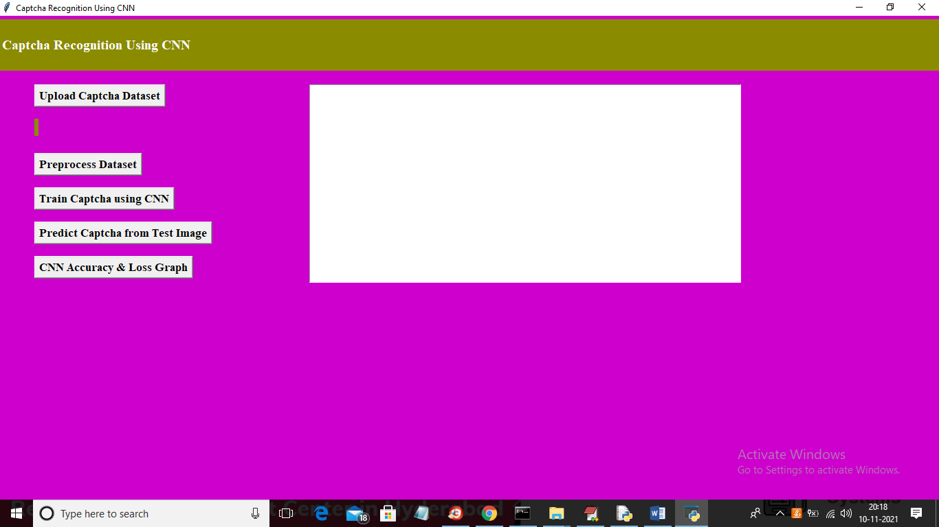
In above screen click on ‘Upload Captcha Dataset’ button to upload dataset and to get below screen
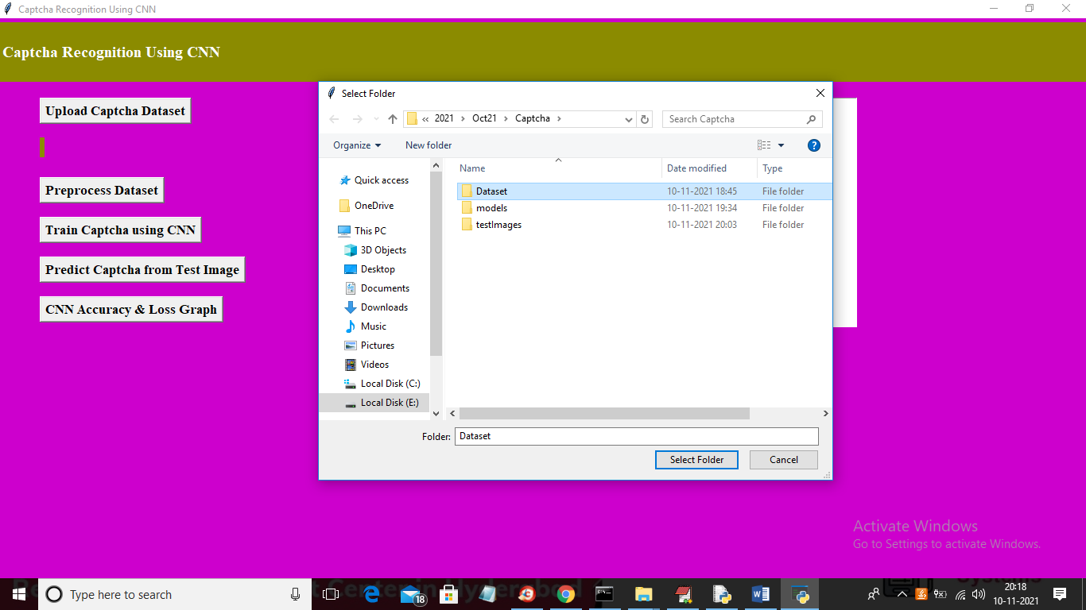
In above screen selecting and uploading ‘Dataset’ folder and then click on ‘Select Folder’ button to load dataset and to get below screen
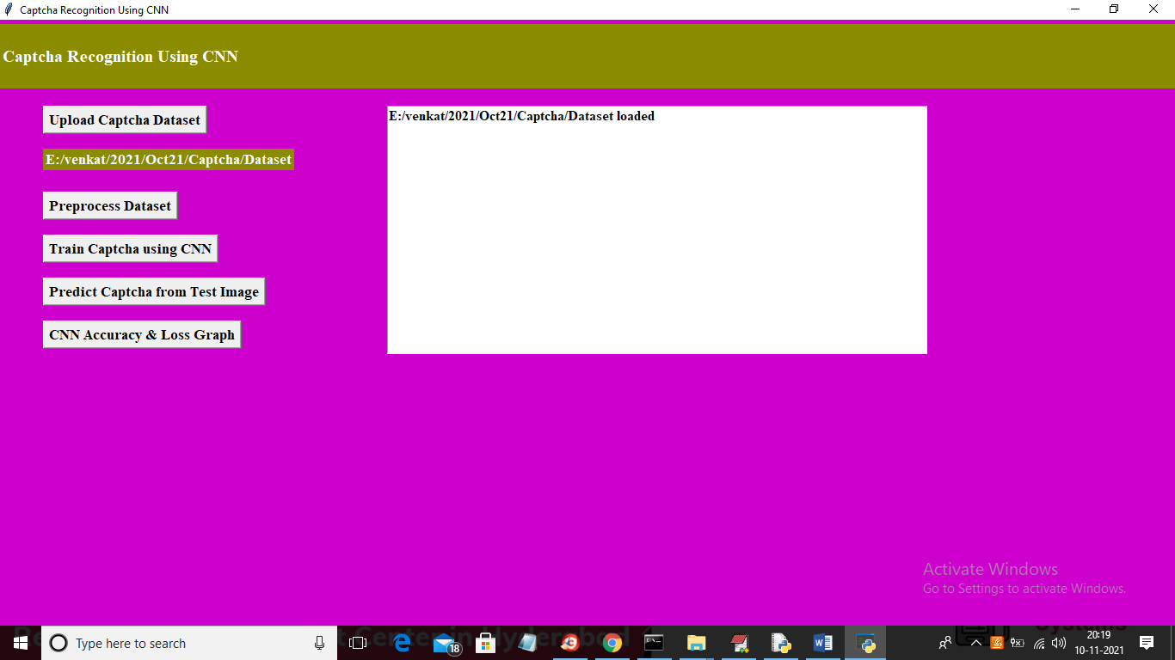
In above screen dataset loaded and now click on ‘Preprocess Dataset’ button to process all images and to get below screen
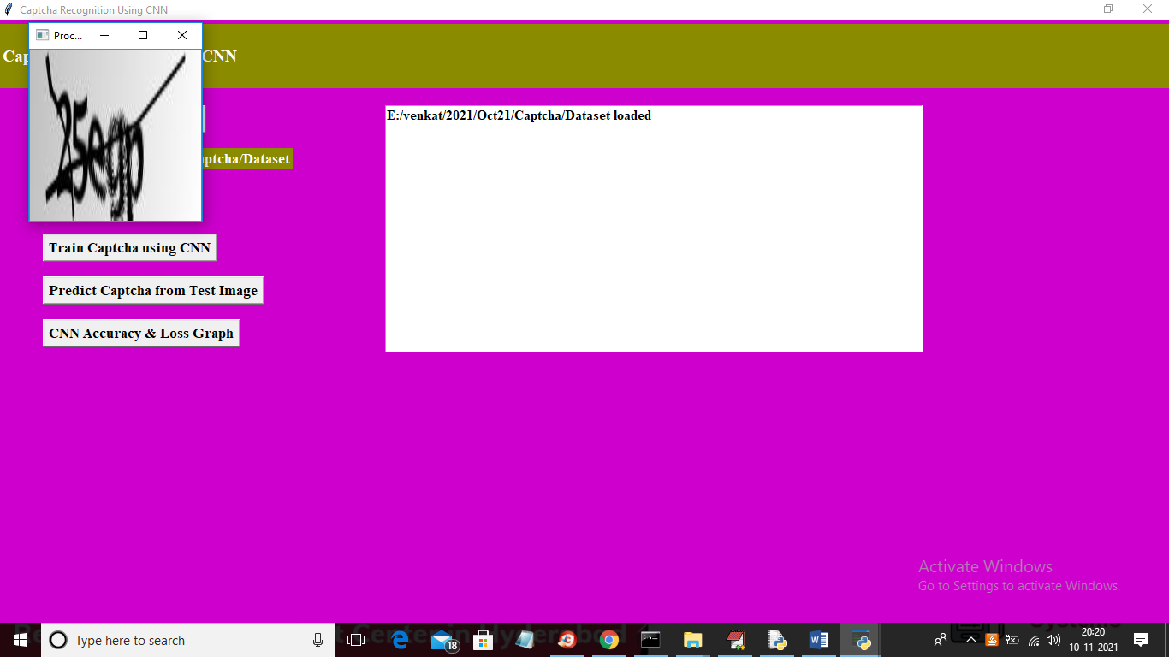
In above screen displaying sample grey scale normalized image and then close above image to get below output
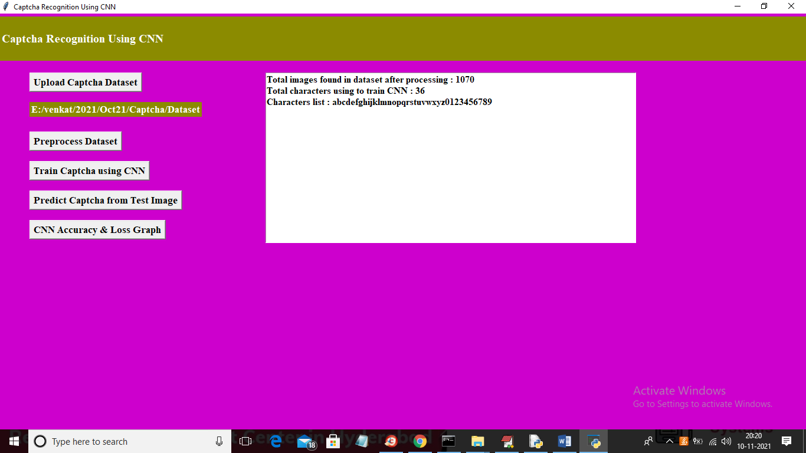
In above screen we can see total dataset images and characters used to train CNN model. Now dataset is ready and now click on ‘Train Captcha using CNN’ button to train CNN model and calculate loss value
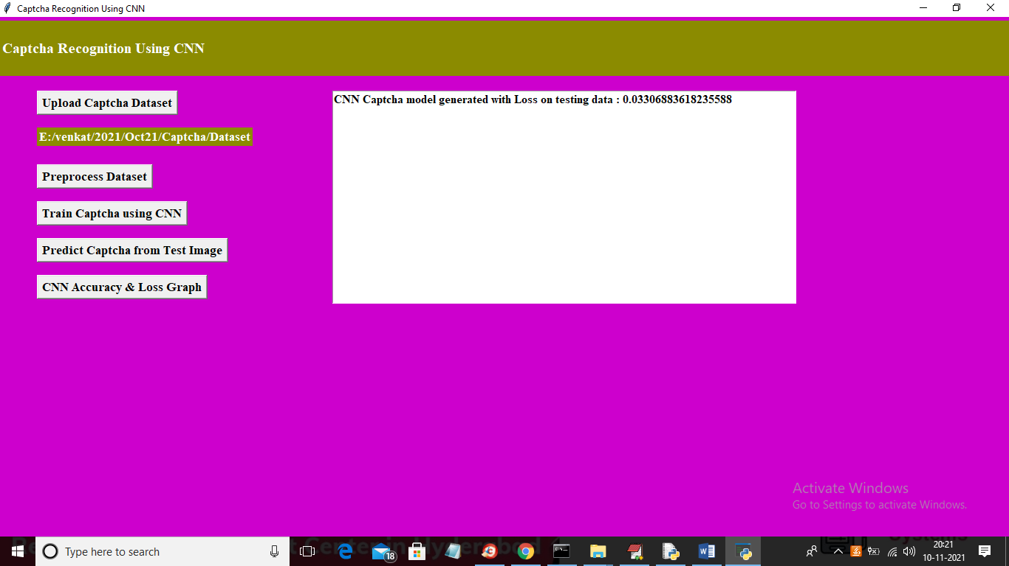
In above screen we got CNN loss value as 0.033 so accuracy will be 100 – 0.033 = 99.967 and now model is ready and now click on ‘Predict Captcha from Test Image’ button to upload test image like below screen
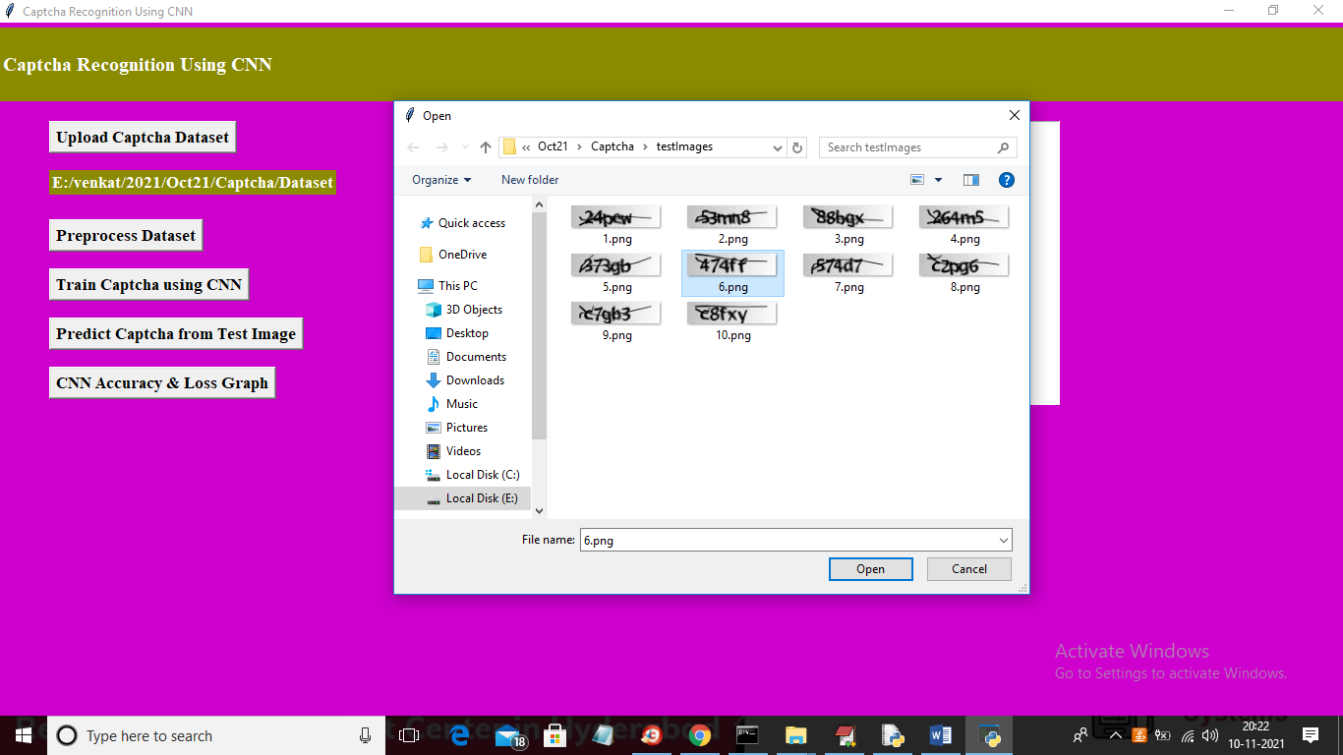
In above screen selecting and uploading ‘6.png’ image and then click on ‘Open’ button to get below output
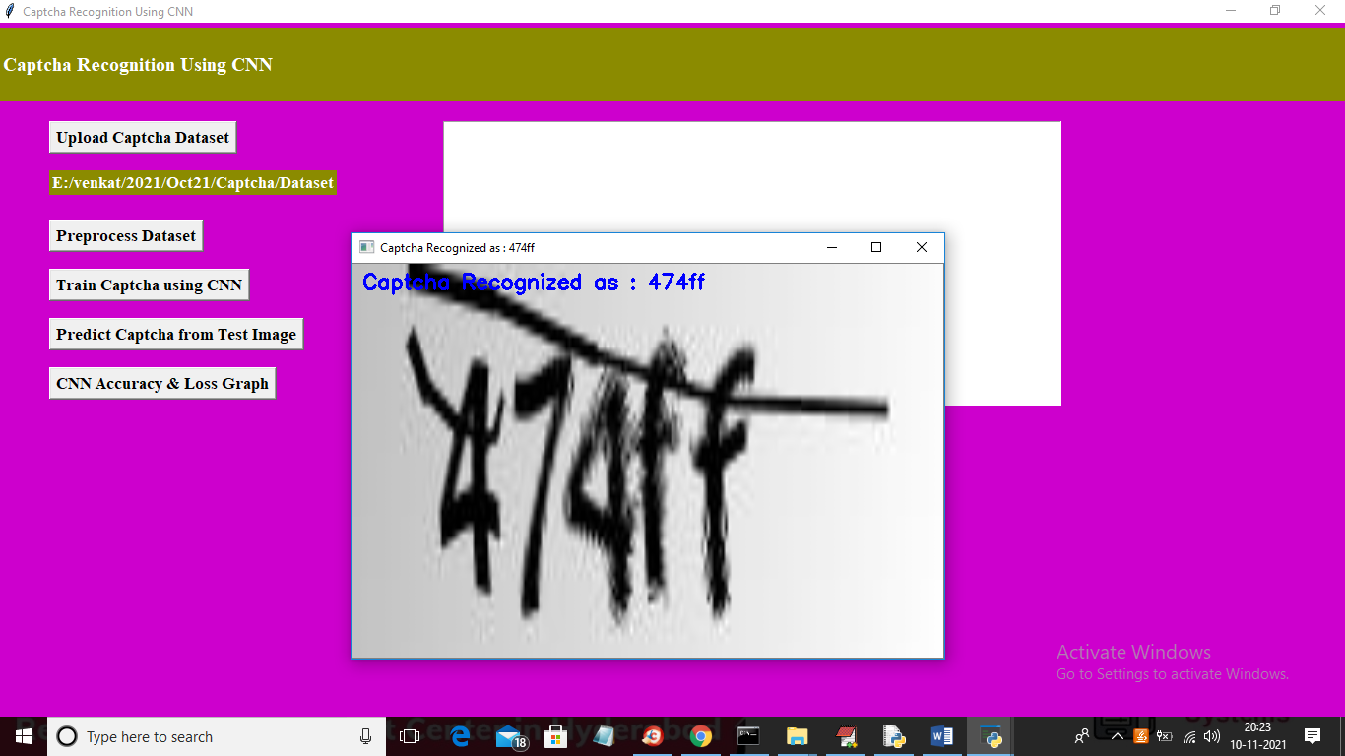
In above screen Captcha is recognized as ‘474ff’ and similarly you can upload other images and test them. Now close above image and then click on ‘CNN Accuracy & Loss Graph’ button to get CNN training performance
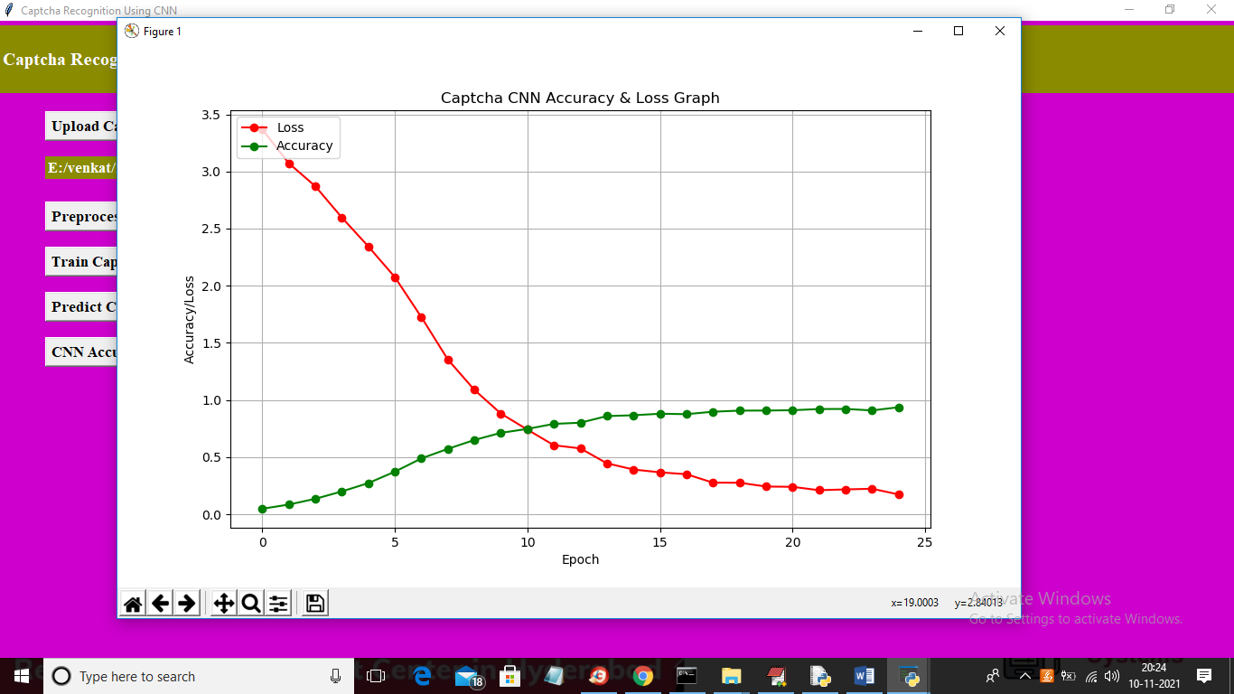
In above graph x-axis represents EPOCH and y-axis represents accuracy/loss values and in above graph red line represents LOSS and green line represents accuracy and in above graph we can see with each increasing epoch accuracy value got increased and loss values got decreased which indicates CNN trained accurately on dataset.

8. CONCLUSION
Even though there are many kinds of CAPTCHAs, text-based CAPTCHAs are commonly used even if they are not the most secure option because they are cheap, convenient, and user friendly. Because text-based CAPTCHAs are more vulnerable to attacks and less secure than originally intended, improvements need to be made. Finding ways to solve text-based CAPTCHAs that are more efficient and more accurate is a great way to increase their security by finding their weaknesses. Overall, CNN is an efficient and accurate method of recognizing CAPTCHAs, and there could be more developments in using it to improve the security of text-based CAPTCHAs. To determine if CNN networks which have less structural complexity and shorter runtimes could be used to accurately recognize CAPTCHAs with character adhesions and background noise, our team constructed three CNN networks that are structurally more efficient than many of the current methods of high accuracy CAPTCHA recognition, and tested them on three different CAPTCHA datasets. The results show that even though these networks have less structural complexity, they are still capable of reaching high accuracy recognition, such as 94.67% accuracy for Network 1 on the first dataset, with only 1070 samples from each dataset selected for training. Even on instances where the accuracy is low, we believe the accuracy could be greatly improved with more training. These results suggested that the third dataset, which is composed of all 26 upper case and lower case letters and 10 digits randomly with character adhesions, slant, and dots and lines in the background as distractions, was considerably harder for the models to recognize compared to the other two datasets, and it required more training to reach a desired accuracy. The future security of text-based CAPTCHAs remains an open problem and is part of our ongoing work.

9.REFERENCES
[1] Bursztein, E., Bethard, S., Mitchell, J.C., Jurafsky, D., Fabry, C. (2010) How good are humans at solving CAPTCHAs? a large scale evaluation. IEEE S&P ’10.
[2] Lecun, Y., Bottou, L., Bengio, Y., Haffner, P. (1998) Gradient-based learning applied to document recognition. Proceedings of the IEEE.
[3] Goodfellow, I.J., Bulatov, Y., Ibarz, J., Arnoud, S., Shet, V. (2014) Multi-digit number recognition from street view imagery using deep convolutional neural networks. ICLR.
[4] Zhang, L., Huang, S.G., Shi, Z.X., Hu, R.G. (2011) CAPTCHA recognition method based on LSTM RNN. Pattern Recogn., 1: 40–47.
[5] Yan, J., Ahmad, A.S.E. (2008) A low-cost attack on a Microsoft CAPTCHA. Proceedings of the ACM Conference on Computer and Communications Security, 543–554.
[6] Stark, F., Hazirbaş, C., Triebel, R., Cremers, D. (2015) Captcha recognition with active deep learning. GCPR Workshop on New Challenges in Neural Computation.
[7] Wang, J., Qin, J.H., Xiang, X.Y., Tan, Y., Pan, N. (2019) CAPTCHA recognition based on deep convolutional neural network. Math. Biosci. Eng., 16: 5851–5861.
[8] Kaggle. (2018) CAPTCHA Images. https://www.kaggle.com/fournierp/captcha-version-2-images.
[9] Kaggle. (2020) CaptchaImages1070. https://www.kaggle.com/datascientistsohail/captchaimages1070.

